**Impact of changes in water availability on water quality: a data-based investigation of Critical Zone subsurface and vegetation interactions**

A Thesis Proposal Presented

by

Niara Hicks

to

The Faculty of the Department of Geography and Geosciences

of

The University of Vermont

May 4th 2023

Accepted the Faculty of the Department of Geography and Geosciences, the University of Vermont, in partial fulfillment of the requirements for the degree of Master of Science specializing in Geology.

The following are members of the Thesis Committee:

_________________________

Advisor

Julia Perdrial, PhD

_________________________

Kristen Underwood

_________________________

Beverley Wemple

_________________________

**Abstract**

The Critical Zone (CZ) spans from the bottom of groundwater limits up to the tops of trees and is the place where the hydrosphere, biosphere and atmosphere interact to sustain life through many important ecosystem services. Water of high quality is one important ecosystem service; however, disturbances can disrupt the CZs capacity to sustain such services. Further, multiple responses to disturbances across layers of the CZ can interact and determine how and if the CZ will resist and/or recover. Climate change is one of the most significant disturbances we face today, and I will build on existing research that found that water quality will degrade for locations where climate becomes dryer and warmer. For this I will use a data-based approach to test my overarching hypothesis that streamwater quality is a function of the combined physical CZ properties and vegetation resilience. I will use data from a new database that contains catchments attributes, water quality and atmospheric deposition data for the entire continental U.S. and for several decades since 1985. My data exploration will be hypotheses informed but will embrace the iterative nature of data-driven research that includes adjustments on scales and questions based on emerging findings.

1. **Introduction**

The Critical Zone (CZ) is defined as the area on the Earth that spans from the bottom of groundwater limits up to the tops of trees (Brantley et al., 2017). This is where the hydrosphere, biosphere and atmosphere interact to sustain life through many important ecosystem services (Fig 1a, Abbott et al., 2023). Water movement through the CZ is an integral part of this CZ functioning and a multitude of complex and coupled processes govern water amount and quality: water enters the system in the form of precipitation, that is either evaporated, transpired by plants, stored in soil pores, percolated through soil and regolith to fill groundwater stores, and/or fed to streams (Fig 1b, Chorover et al, 2007). Through this system, the CZ governs several interconnected ecosystem services, such as water quality, water quantity, but also vegetation health and ecosystem nutrition.

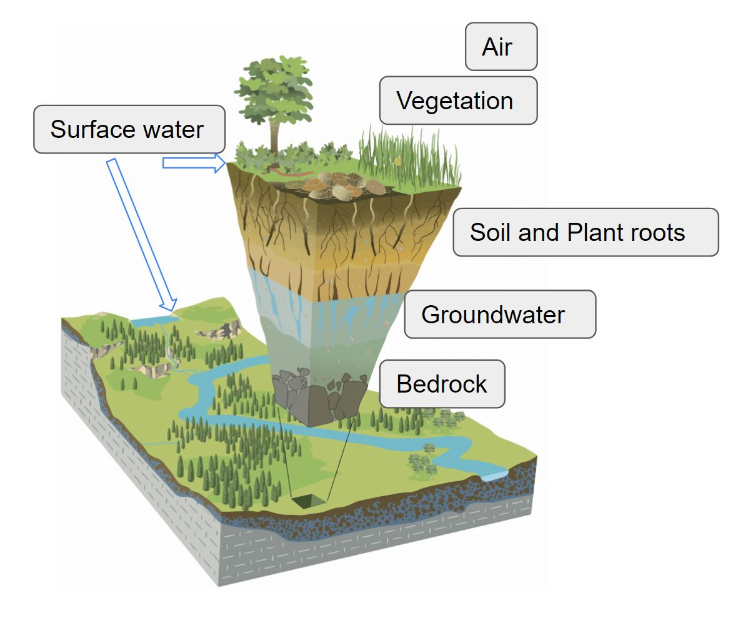 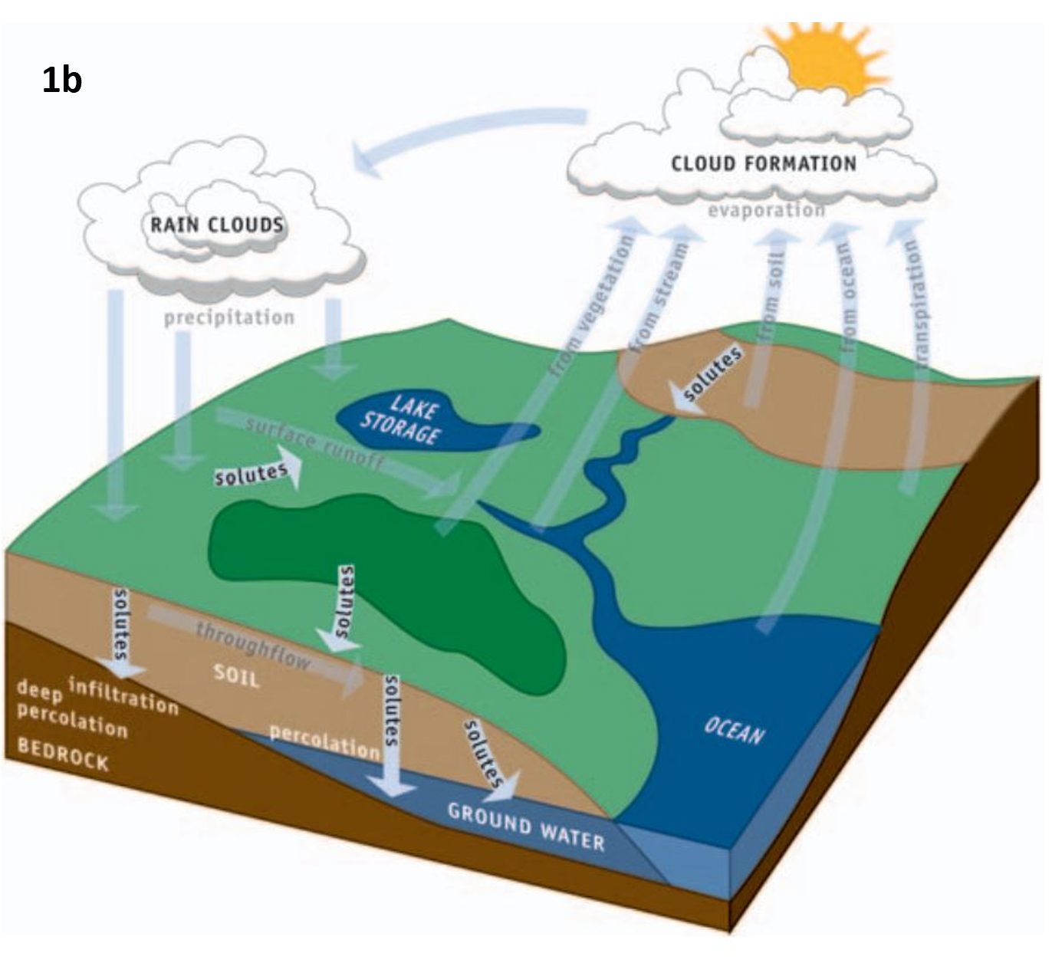

***Figure 1:*** *(a) the Critical Zone as an integrative system where geosphere, hydrosphere, biosphere, and atmosphere interact (modified from Chorover et al., 2007). (b) The water cycle showing the cycle of evaporation, precipitation, vegetation and soil storage and fluxes and stream flow (Brantley et al., 2017).*

b)

a)

Disturbances are environmental stresses that can shift overall conditions and functioning of the CZ and they can fundamentally disrupt the balance of this system and its capacity to sustain these ecosystem service (Abbott et al., 2023). Climate change is one major disturbance impacting the CZ across the globe (Jaramillo et al., 2022). The response to such a disturbance can be summarized in the concepts of resistance, recovery, and resilience (Abbott et al., 2023). Resistance describes how successfully a catchment system can maintain its state during a disturbance, recovery refers to the capacity of the CZ to return to its pre-disturbed state, and resilience is the combination of both resistance and recovery (Abbott et al., 2023). The concept of multidimensional resilience captures the complex dynamics when different parts of the CZ respond differentially to these disturbances and impact each other (Fig. 2, modified from Abbott et al., 2023), which can vary significantly based on disturbances and CZ structure.

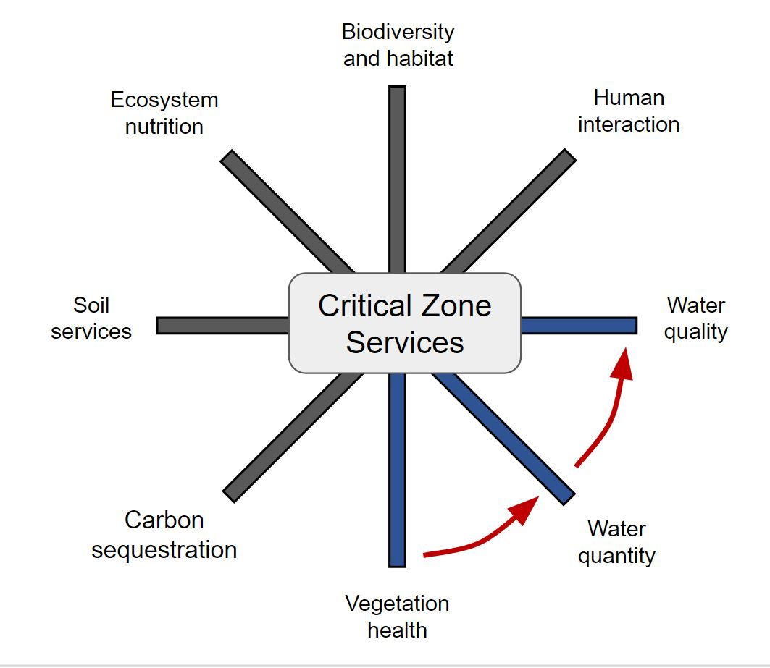

***Figure 2:*** *Conceptual representation of interconnected of resilience and several ecosystem services (separate spokes). My**project will focus on the interactions between vegetation health, water quantity, and water quality (spokes in blue, modified after Abbott et al., 2023).*

For example, across the continental United States (CONUS), variations in CZ attributes such as bedrock, topography, soil thickness or vegetation, may result in diverse local environments that might resist or recover very differently, thus exhibiting variations in CZ resilience. Additionally, these locations experience different and sometimes overlapping disturbances. For example, climate change causes changes in precipitation, potential evapotranspiration (PET), soil moisture, and resulting stream flow in the coming century (Jaramillo et al., 2022), thus the amount of water in these pathways and reservoirs vary. In water limited catchments, vegetation can adapt to be more efficient in water uptake (Mehra et al., 2022), leaving less water available for storage in the subsurface or export via streams. This way, resilience of vegetation can impact resilience of stream water quality, connecting various ecosystem services based on ecoregions and other CZ characteristics (Hay et al., 2011). With my work, I will be using a data-based approach to investigate how different layers of the CZ respond to such shifts in precipitation across the CONUS and evaluate connections between water and vegetation resilience.

1. **Background** 
   1. **Stream water quality**

Stream and river water quality is important because it affects many aspects of the environment, aquatic life, habitats, and biodiversity (Ríos-Touma et al., 2022). Streams also have important implications for human life, as we depend on stream and river water for drinking water, recreation, and much more. Furthermore, streams can be an important indicator of CZ functioning, as they offer an integrated signal of the land area they are draining. Thus, streams are monitored continuously by government agencies like the U.S. Geological Survey (USGS) to collect information on water quality and track potential changes.

Several parameters can signal the quality of water, including pH, temperature, dissolved oxygen and the concentration of solutes or particles (i.e. turbidity). For example, high levels of nutrients like nitrate may result in algae blooms that impact oxygen availability of aquatic wildlife (Akpor et al., 2014). Increasing water temperature can be harmful for aquatic species because of reduced oxygen solubility. Increased total dissolved solute (TDS) concentration and increased turbidity can cause issues with water treatment, harm aquatic wildlife and/or limit photosynthetic activity due to light limitation (Verspagen et al., 2014).

In the context of shifts in precipitation and changes in water availability with climate change, water quality might degrade. For example, a recent study by Li et al., (2021) found that river health will significantly decline in places where climate becomes warmer and dryer. In this study, the authors used existing data for 506 minimally impacted rivers across the CONUS to determine that solute concentrations decrease as river discharge increases (Li et al., 2021). These solutes can include biogenic solutes [e.g. Total Organic Carbon (TOC), Dissolved Organic Carbon (DOC), Total Nitrogen (TN), Total Organic Nitrogen (TON), Nitrate (NO3), and Dissolved Organic Nitrogen (DON)], typical geogenic solutes (Na, K, Si, Mg, Ca) as well as species of varied origin (e.g. Al, Cl, Sulfate (SO4), or Bicarbonate (HCO3)]. In turn, their results indicate that in warmer and dryer climate, biogeochemical reactions within the CZ will produce more solutes, while at the same time water as diluting factor might be lacking, resulting in overall higher concentrations and degrading water quality (Fig 3).

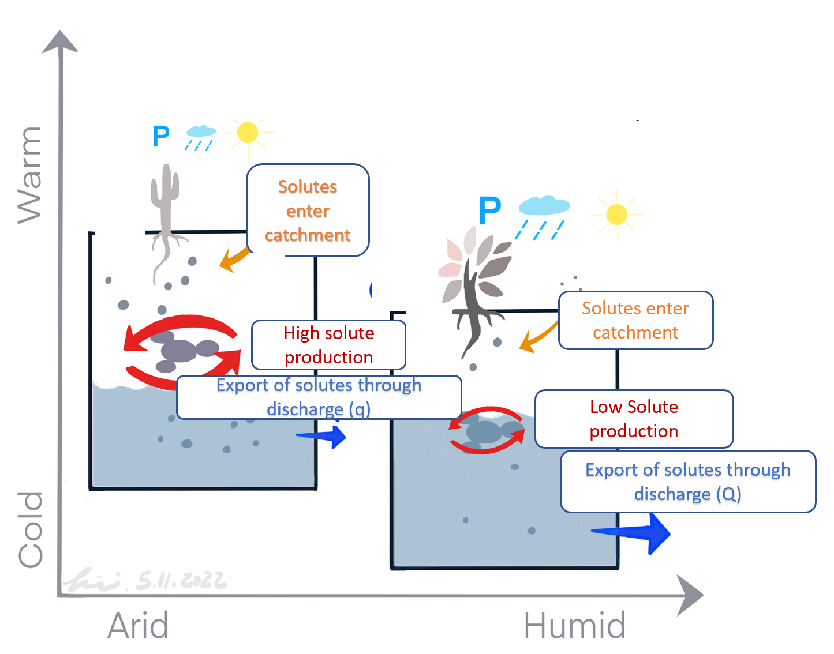

***Figure 3****:Conceptual model of water and solute dynamics under different climate conditions; warm and dry vs. cold and humid. P represent precipitation. Catchments that will become warmer and dryer will produce more solutes due to subsurface interactions that are not diluted during export and water quality degrades. Catchments that become more humid will have less subsurface reaction time and water available for flushing and dilution, improving water quality (Figure from Li et al., 2021).*

* 1. **Interconnection between CZ characteristics, climate and water**

The way water availability might impact stream water quality is not only a function of shifts in climate, but also a function of the multitude of interconnected processes in the CZ, and the resilience of each of these aspects (Creed et al., 2014; Abbott et al., 2023). For example, CZ subsurface characteristics can have important implications on the water balance, as shown in a study by Pfister et al. (2017), who found that bedrock with higher permeability generally had higher discharge than locations with low bedrock permeability. This might possibly increase stream water resilience if more water is available for diluting solutes.

In turn, vegetation strongly impacts (and is impacted by) the water balance, as plant transpiration (part of evapotranspiration) removes water from groundwater and soil stores (Lowry & Loheide II, 2010). When vegetation is water-stressed, some species can adapt by responding with “hydrotropism” - a process whereby roots grow towards sources of water (Duan et al., 2010, Dietrich, 2018). This capacity increases vegetation resilience in face of a drought, but might have consequences for water quality in streams because solutes might become more concentrated (Li et al., 2021). These examples show some of the complex effects that shifts in climate can have and where multiple dimensions of CZ resilience can interact.

The dynamics of climate and water availability for the generation of stream flow is captured in the conceptual budyko framework that expresses the balance of water and energy at the Earth's surface (Budyko, 1974). In this concept, the aridity index (or dryness index) is the ratio between potential evapotranspiration (PET) and precipitation (P). The evaporative index is the ration between actual evapotranspiration (AET) and P and, when plotted against each other, these values define a space that can be separated into water vs. energy limitation (Fig. 4). A catchment having a dryness index of less than one is considered wet because P exceeds evapotranspiration (ET) losses and water is not the limitation for CZ function (Creed et al., 2014). In contrast, a catchment having a dryness index greater than 1 will plot on the right side of that line, indicating that it is water limited or dry.

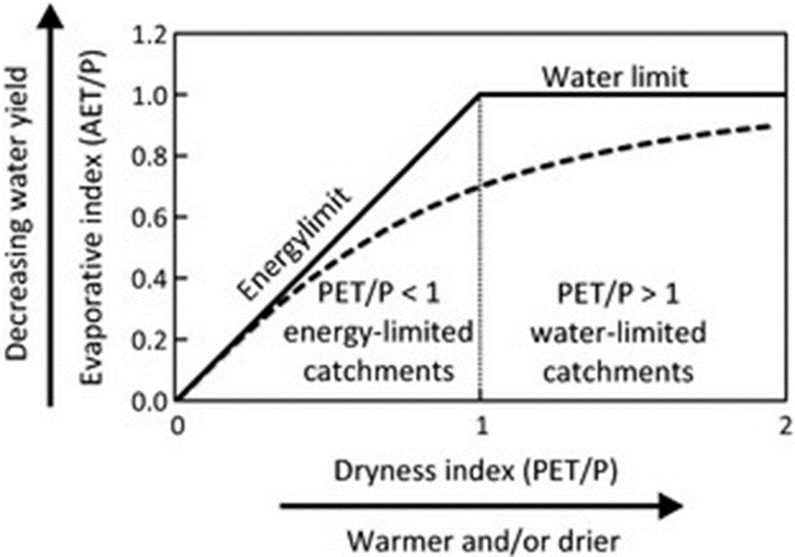

***Figure 4:*** *Budyko curve diagram. The two bolded lines in the diagram represent the extent of how much water and energy can naturally occur in a system. All catchments will plot below the water limit line unless there is water coming into the system in ways other than precipitation. Similarly, all catchments will plot underneath the energy limit line unless water is taken out of the system in ways other than discharge (Figure from Creed et al. 2014).*

Creed et al. (2014) has utilized the Budyko framework to assess the impact of warming climate on the annual water balance of precipitation, evapotranspiration (ET), and overall water yield for forest catchments. By integrating hydrological and meteorological data with the Budyko model, these authors suggest predictive capabilities of the framework for changes in water partitioning during climate warming (Creed et al., 2014)

Another study simulated climate change for watersheds in the western U.S. and showed increase in water yield and the largest decrease in PET (Heidrai et al., 2020) for locations in the west with mountain, basin, and plateau land forms. On the other hand, catchment basins with high evaporative indexes had low water yields were predominantly in the south, southwest and northern central U.S. (Heidrai et al. 2020). These catchments were also most likely to encounter long periods of drought. This study revealed that catchment characteristics such as the general environment and land form influence a watershed’s reaction to changes in climate (Heidrai et al., 2020).

Another study investigating the short-term climate regulation on river catchments also used the Budyko framework to classify dilution patterns of dissolved inorganic carbon (DIC). The authors found that for DIC, concentrations were lower at sites with higher amounts of discharge (Stewart et al., 2022). They also determined that the aridity index is overall higher in the western U.S. than the eastern U.S. DIC concentrations were higher in these places with higher aridity indexes (Stewart et al., 2022).

* 1. **Data-driven approach, objectives and hypotheses**

Many of these aforementioned examples use existing long-term data to identify patterned responses of watershed in the light of environmental change, however, such data-driven investigations on the complex interactions between CZ structure and multidimensional resilience are still rare. One reason for this is that data on both CZ characteristics, streamflow and water quality are often not available in combination. A new data set bridges this gap and now integrates existing data from 506 catchments across the CONUS from the “Catchment Attributes and Meteorology for large sample studies (CAMELS)” data (Addor et al., 2017), with stream water discharge, water chemistry measurements from the U.S. Geological Survey as well as atmospheric deposition data retrieved from the National Atmospheric Deposition Program (Sterle et al., 2023). This new database is called CAMELS-Chem and allows users to retrieve and investigate data on different layers of the CZ, in different regions across the CONUS, for timeframes between 1985 and 2018.

One major feature of such data-driven approaches is the iterative nature of the investigation where data exploration or hypotheses might be a starting point, however, questions and scales of inquiry will be refined during the research process in an iterative fashion (Figure 5). This way, new information and emerging patterns are included and might form the basis for refined hypotheses that might be tested at a specific scale. With my research, I plan on investigatinggeneralizable patterns to evaluate possible connections between subsurface CZ characteristics (e.g. bedrock composition and physical properties), vegetation metrics and stream water quality, to ultimately identify potentially vulnerable systems for further investigations. I have developed a set of guiding hypotheses as a starting point for data exploration, however, recognizing the iterative nature of my approach, I expect adjustments on the way as I explore the dataset.



***Figure 5:*** *Diagram of the iterative nature of data-based investigations. Many of the yellow rectangles represent a possible starting point, allowing hypothesis testing to one of many steps in the investigative process (figure by Kristen Underwood and Shaurya Swami).*

**Overarching hypothesis**: streamwater quality is a function of the combined physical CZ properties and vegetation resilience.

**Specific hypotheses:**

1. Streams draining catchments underlain by highly permeable materials (e.g. mixed sedimentary rocks) have the highest water quality because water enters streams readily, diluting solutes effectively. For locations where conditions become progressively dryer, water quality will be relatively less impacted than for catchments with low permeability.
   1. Potential edit for above: Hypothesis 1: Bedrock permeability affects (mean?) water quality as measured by stream solute concentration by impacting runoff volumes. Prediction 1: Thus, water quality will be higher in catchments with more permeable bedrock than in catchments with less permeable bedrock when aridity indices are similar.
2. Streams draining catchments with vegetation with greater rooting depths and deep soils (higher degree of vegetation resilience) have decreased water quality because competition for water leads to higher solute concentration in streams.
3. Water quality resilience in response to climate change is highest in locations where rooting depth is shallow and CZ porosity and permeability is high.

**3. Methods**

**3.1. Data sources and computational tools**

I will use data of the CAMELS-Chem data set that contains over 50 catchment attributes, including hydrologic indices and geologic characteristics for 671 catchments across the CONUS (Sterle et al. 2023, Addor et al., 2017).  Further, CAMELS-Chem includes the following 18 common stream water chemistry constituents: Al, Ca, Cl, DOC, TOC, HCO3, K, Mg, Na, TDN [NO3, + nitrite (NO2), + ammonia (NH3) + organic-Nitrogen], TON, NO3, Dissolved Oxygen (DO), pH, Si, SO₄, and water temperature for over 506 minimally impacted headwater catchments. In many cases, these data date back several decades and will allow me to assess changes in water quality over time (Sterle et al. 2023). Collaboration with data scientists from the same project will support me in retrieving data.

To assess water quality, I will use specific parameters such as DO, pH and temperature (T), but also specific solutes of concern, such as DOC (leading to water browning) and nitrate (leading to algal blooms). To assess shifts in combined solute concentrations, I will calculate TDS and ionic strength (IS) for each location and time point where all solutes are available, as these metrics can serve as broad water quality indicators (Berner & Berner, 1996).

From this data set, I will also obtain catchment attributes such as bedrock lithology, root depth, porosity, permeability, and climate indices, that I can investigate against solute concentration for these catchments. Bedrock lithology varies across the CONUS and is included as acid plutonic, acid volcanic, basic volcanic, carbonate sedimentary, intermediate plutonic, intermediate volcanic, metamorphic, mixed sedimentary, pyroclastic, siliciclastic sedimentary, and unconsolidated sediment. However, some of these bedrock lithologies are only present in a few locations (e.g. volcanic rocks in the cascades), requiring some refinement on scales of inquiry based on data availability (see also steps in my research and preliminary results).

I will use R with the RStudio interface to complete all necessary calculations (such as TDS) as well as the plots for Budyko space. For the latter I will use this equation (Budyko, 1974):

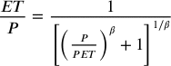

This equation states that the evaporative index (ET/P) is positively correlated to the aridity index (PET/P). The curve produced from the relationship between ET/P and PET/P is changed by the parameter *β,* which is dimensionless.  Mean annual precipitation (P), PET, and mean annual discharge are all available from the CAMELS-Chem database. These analyses will support energy/water status of catchments while also allowing us to compare multiple catchments at once.

**3.2. Steps in my research**

I will begin with a hypothesis informed exploratory data analysis and will determine more clearly which locations have the necessary data. For example, I will subset the CAMELS-Chem dataset to evaluate the influence of CZ subsurface characteristics, and other parameters such as length of record, number of samples and ecoregions. I have already began exploring variations in bedrock lithology across climate gradients and other catchment (Figure 6, see also preliminary results).

To test the hypotheses on permeable materials (e.g. mixed sedimentary rocks) and water quality (hypothesis 1), I will subset the dataset for sedimentary rocks and evaluate their water quality on averages as well as over time. I will use the Budyko space to visualize potential shifts in catchment wetness vs. water quality. To do this, I will track catchments placements on the budyko curve to see how catchments with similar regional climates and differing bedrock lithology vary in their dryness index statuses (Table 1). With the temporal aspect, I will also see if and/or how catchments with similar regional climates and varying bedrock lithology changed over an interannual or decadal period (Table 1). To investigate the role of vegetation resilience, I will subset data by different types of soil depth and rooting depth and evaluate potential impacts on water quality through comparison (hypothesis 2). Whether I’ll be able to test the effect of combinations between rooting depth and CZ porosity on water quality (hypothesis 3) will depend on the data availability. These explorations will likely lead to refining scales of references, adjusting hypotheses and further exploration.

|  |  |  |  |
| --- | --- | --- | --- |
| **Focus** | **Hypotheses 1: Subsurface permeability** | **Hypothesis 2:**  **Vegetation competition for water** | **Hypothesis 3: Combined CZ resilience over time** |
| **Constant** | Regional climate  (e.g. Mean average precipitation, snow fraction) | Bedrock lithology, regional climate | Combinations of Bedrock lithology, climate, and vegetation metrics for select locations |
| **Variable** | Bedrock lithology  (E.g. Geological class, subsurface permeability) | Vegetation metrics  (rooting depth, leaf area index, seasonality) |
| **Changes over time?** | Possible: Assess averages (all years) and interannual or decadal shift in water quality | | Yes: assess interannual or decadal shift in water quality |
| **Water amount** | Discharge (Q) | | Discharge (Q), Aridity index (PET/P), evaporation index (AET/P) |
| **Water quality** | Major geogenic solutes (Na, K, Si, Ca, Mg), TDS, ionic strength, pH, DO, biogenic and anthropogenic solutes | | |

*Table 1: Preliminary plan for data and analysis involved for testing each hypothesis. The “constant” row shows what variables will be held constant for the analysis. The “variable” row explains which variables will be changed for the analysis. “Changes over time?” asks if there could be a difference in the changing variable when comparing data from different years or decades. Water amount refers to assessing how water quantity might change and influence water quality.*

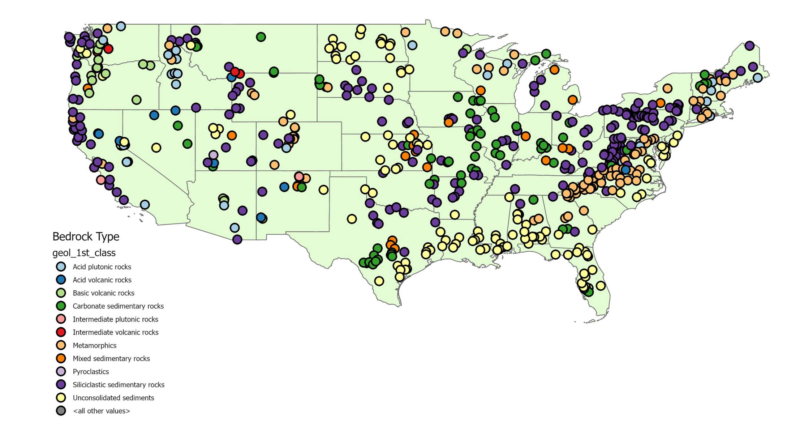

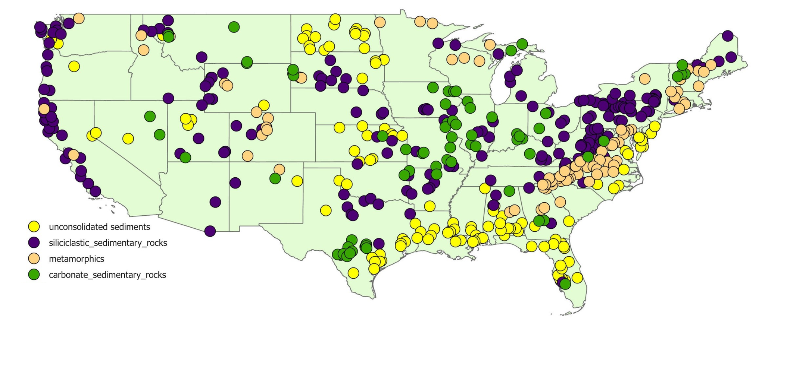

***Figure 6:*** *a) Map of all bedrock lithologies across the CONUS. b) Map of lithologies with enough data and presence across climatic gradients to test my hypotheses.*

a)

b)

**3.3. Contribution to data collection and field skills and timeline**

My research is based on analyzing existing data, however, without intense data collection efforts by others, I would not be able to have access to any of these existing data. To contribute to data collection for future use, I will join several fieldwork campaigns at Sleepers River Research Watershed (SWWR) and the Illilouette Creek Basin (ICB). At these two sites, I will learn ecohydrological methods, sample, and data collection. The methods I will learn at these sites include stream and precipitation sampling, groundwater sampling, and sensor data downloading. These data might not be used in my research directly but will contribute to future data analyses by the CZ community. Further, this approach allows me to gain skills in sample and data collection alongside with data analyses skills through this project that will help me with my future career goals.

|  |  |
| --- | --- |
| **Season/Month** | **Task** |
| Spring 2023 | Proposal Defense |
| Throughout the year | Join USGS at SRRW for fieldwork |
| May, June 2023 | Exploratory data analyses, assessing data availability  Present at the CZNet allhands meeting |
| July 2023 | ICB visit for ecohydrological fieldwork  Beginning to investigate temporal trends in data |
| August 2023 | Assessing Budyko framework for analyses, refining hypotheses |
| Fall 2023 | Progress Report |
| December 2023 | Present Progress at AGU |
| Winter 2024 | Write thesis |
| Spring 2024 | Defend thesis |

***Table 2:*** *Ideal timeline of my research.*

1. **Preliminary data**

Figures 7 display preliminary calculated average subsurface porosity and rooting depth (50th percentile) for catchments with the four main bedrock types I selected (469 out of the 506). Locations underlain with metamorphic rocks had the lowest average porosity value of 0.03, followed by carbonate sedimentary rocks with 0.08, and siliclastic sedimentary rocks with 0.16. Unconsolidated sediments have the highest subsurface porosity with 0.20 (displayed as fraction where 1=100% pore space). These data indicate that the main bedrock types display enough variability in porosity to test related hypotheses.

Metamorphics have the highest values for average root depth with a value of 0.20m, followed by unconsolidated sediments and siliclastic sedimentary rocks with 0.18m, and lastly carbonate sedimentary rocks with 0.16m.

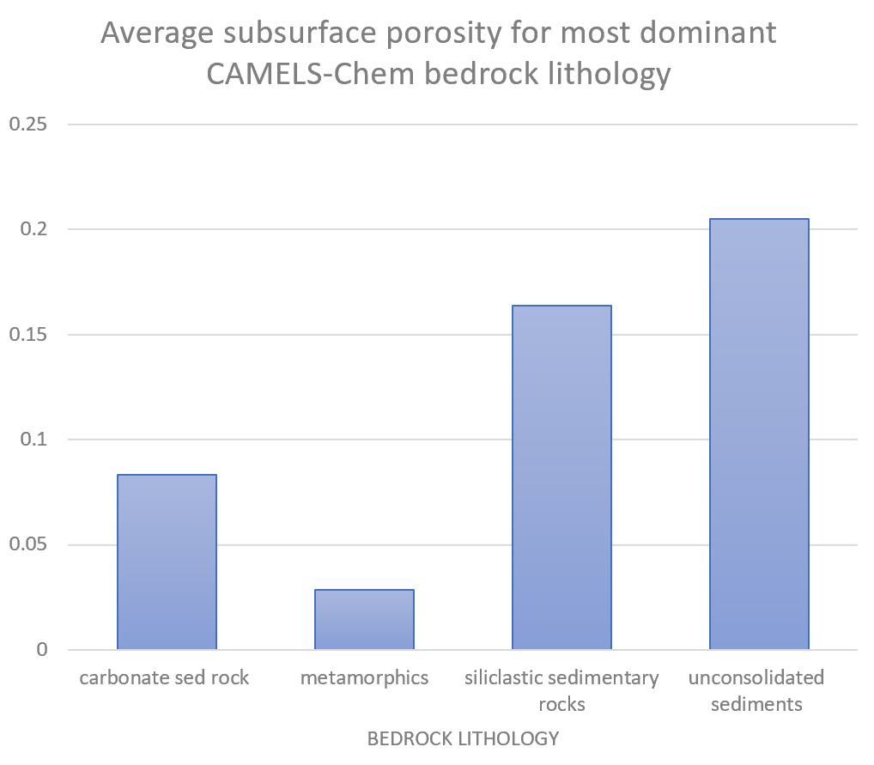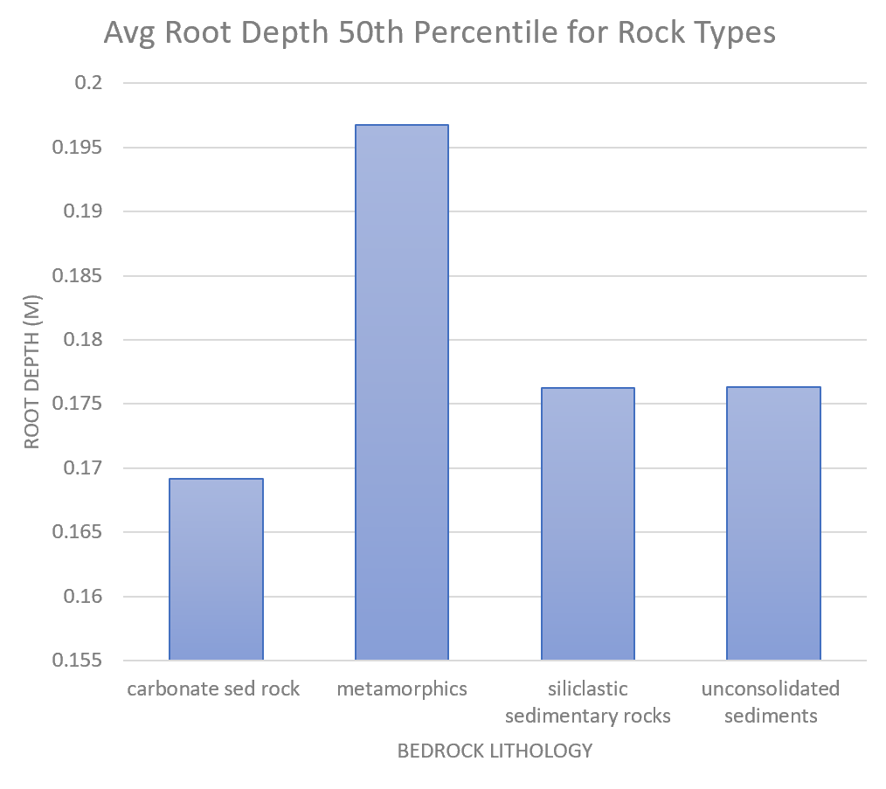

***Figure 7****: a) Average subsurface porosity by bedrock type. b) Average rooting depth (50th percentile) for each bedrock type.*

Figure 8 shows an example budyko plot for how water quality can be assessed in this context (here DOC). The resulting plot indicates that energy-limited or wet catchments tend to have lower DOC concentrations (symbol size), which is in agreement with the dilution hypothesis.

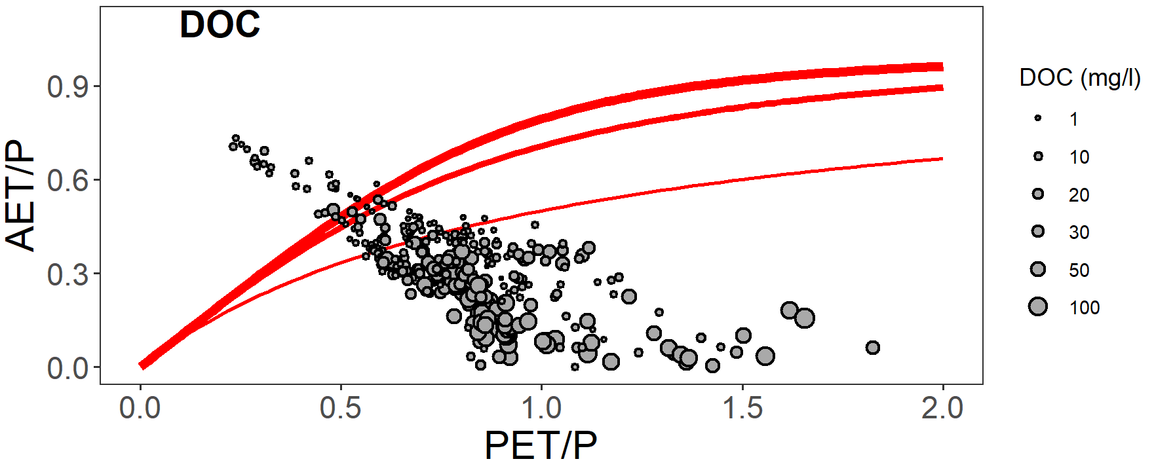

***Figure 8****: example budyko plot of the CAMELS-Chem catchment DOC concentrations. Most of the catchments have values less than 10 mg/L. The catchments are also mostly not on the ideal budyko curve. Most of the catchment with small DOC concentrations have an aridity index less than 1, indicating that they are energy-limited/wet.*

References

Abbott, B. W., Underwood, K. L., Seybold, E. C., Kincaid, D., Hamshaw, S. D., Lee, R. M., Rizzo, D. M., Brown, B., Toolin, R., Chorover, J., Li, L., Lewis, G., Sayedi, S. S., Clair, S. St., Buck, R. L., Aanderud, Z., Brahney, J. L., Nixon, R. S., Wang, W., … Perdrial, J. N. (2023). *Resistance, recovery, and resilience: Rethinking the three Rs of survival in the Anthropocene* [Preprint]. Preprints. https://doi.org/10.22541/essoar.167390526.69780816/v1

Addor, N., Newman, A. J., Mizukami, N., & Clark, M. P. (2017). The CAMELS data set: Catchment attributes and meteorology for large-sample studies. *Hydrology and Earth System Sciences*, *21*(10), 5293–5313. <https://doi.org/10.5194/hess-21-5293-2017>

Akpor, O. B., Otohinoyi, D. A., Olaolu, D. T., & Aderiye, B. I. (2014). POLLUTANTS IN WASTEWATER EFFLUENTS: IMPACTS AND REMEDIATION PROCESSES. *International Journal of Environmental Research and Earth Science*, *3*(3), Article 3.

Berner, E. K., & Berner, R. A. (2012). Global environment: Water, air, and geochemical cycles. Princeton University Press.

Brantley, S. L., McDowell, W. H., Dietrich, W. E., White, T. S., Kumar, P., Anderson, S. P., Chorover, J., Lohse, K. A., Bales, R. C., Richter, D. D., Grant, G., & Gaillardet, J. (2017). Designing a network of critical zone observatories to explore the living skin of the terrestrial Earth. *Earth Surface Dynamics*, *5*(4), 841–860. <https://doi.org/10.5194/esurf-5-841-2017>

Budyko, M. I. (1974). *Climate and life*. Academic Press. <https://scholar.google.com/scholar_lookup?title=Climate+and+life&author=Budyko%2C+M.+I.+%28Mikhail+Ivanovich%29&publication_year=1974>

Chorover, J., Kretzschmar, R., Garcia-Pichel, F., & Sparks, D. (2007). Soil Biogeochemical Processes within the Critical Zone. *Elements*, *3*, 321–326. <https://doi.org/10.2113/gselements.3.5.321>

Creed, I. F., Spargo, A. T., Jones, J. A., Buttle, J. M., Adams, M. B., Beall, F. D., Booth, E. G., Campbell, J. L., Clow, D., Elder, K., Green, M. B., Grimm, N. B., Miniat, C., Ramlal, P., Saha, A., Sebestyen, S., Spittlehouse, D., Sterling, S., Williams, M. W., … Yao, H. (2014). Changing forest water yields in response to climate warming: Results from long-term experimental watershed sites across North America. *Global Change Biology*, *20*(10), 3191–3208. <https://doi.org/10.1111/gcb.12615>

Dietrich, D. (2018). Hydrotropism: How roots search for water. *Journal of Experimental Botany*, *69*(11), 2759–2771. <https://doi.org/10.1093/jxb/ery034>

Duan, Y., Zhang, W., Li, B., Wang, Y., Li, K., Sodmergen, Han, C., Zhang, Y., & Li, X. (2010). An endoplasmic reticulum response pathway mediates programmed cell death of root tip induced by water stress in Arabidopsis. *New Phytologist*, *186*(3), 681–695. <https://doi.org/10.1111/j.1469-8137.2010.03207.x>

Jaramillo, F., Piemontese, L., Berghuijs, W. R., Wang-Erlandsson, L., Greve, P., & Wang, Z. (2022). Fewer Basins Will Follow Their Budyko Curves Under Global Warming and Fossil-Fueled Development. *Water Resources Research*, *58*(8), e2021WR031825. <https://doi.org/10.1029/2021WR031825>

Jost, G., Weiler, M., Gluns, D. R., & Alila, Y. (2007). The influence of forest and topography on snow accumulation and melt at the watershed-scale. *Journal of Hydrology*, *347*(1–2), 101–115. <https://doi.org/10.1016/j.jhydrol.2007.09.006>

Li, L., Stewart, B., Zhi, W., Sadayappan, K., Ramesh, S., Kerins, D., Sterle, G., Harpold, A., & Perdrial, J. (2022). Climate Controls on River Chemistry. *Earth’s Future*, *10*(6), e2021EF002603. <https://doi.org/10.1029/2021EF002603>

Lowry, C. S., & Loheide II, S. P. (2010). Groundwater-dependent vegetation: Quantifying the groundwater subsidy. *Water Resources Research*, *46*(6). <https://doi.org/10.1029/2009WR008874>

Mehra, P., Pandey, B. K., Melebari, D., Banda, J., Leftley, N., Couvreur, V., Rowe, J., Anfang, M., De Gernier, H., Morris, E., Sturrock, C. J., Mooney, S. J., Swarup, R., Faulkner, C., Beeckman, T., Bhalerao, R. P., Shani, E., Jones, A. M., Dodd, I. C., … Bennett, M. J. (2022). Hydraulic flux–responsive hormone redistribution determines root branching. *Science*, *378*(6621), 762–768. <https://doi.org/10.1126/science.add3771>

Orman-Ligeza, B., Morris, E. C., Parizot, B., Lavigne, T., Babé, A., Ligeza, A., Klein, S., Sturrock, C., Xuan, W., Novák, O., Ljung, K., Fernandez, M. A., Rodriguez, P. L., Dodd, I. C., De Smet, I., Chaumont, F., Batoko, H., Périlleux, C., Lynch, J. P., … Draye, X. (2018). The Xerobranching Response Represses Lateral Root Formation When Roots Are Not in Contact with Water. *Current Biology: CB*, *28*(19), 3165-3173.e5. <https://doi.org/10.1016/j.cub.2018.07.074>

Pfister, L., Martínez-Carreras, N., Hissler, C., Klaus, J., Carrer, G. E., Stewart, M. K., & McDonnell, J. J. (2017). Bedrock geology controls on catchment storage, mixing, and release: A comparative analysis of 16 nested catchments. *Hydrological Processes*, *31*(10), 1828–1845. <https://doi.org/10.1002/hyp.11134>

Ríos-Touma, B., Villamarín, C., Jijón, G., Checa, J., Granda-Albuja, G., Bonifaz, E., & Guerrero-Latorre, L. (2022). Aquatic biodiversity loss in Andean urban streams. *Urban Ecosystems*, *25*(6), 1619–1629. <https://doi.org/10.1007/s11252-022-01248-1>

Sterle, G., Perdrial, J., Li, L., Adler, T., Underwood, K., Rizzo, D., Wen, H., & Harpold, A. (2022). CAMELS-Chem: Augmenting CAMELS (Catchment Attributes and Meteorology for Large-sample Studies) with Atmospheric and Stream Water Chemistry Data. *Hydrology and Earth System Sciences Discussions*, 1–23. <https://doi.org/10.5194/hess-2022-81>

Verspagen, J. M. H., Waal, D. B. V. de, Finke, J. F., Visser, P. M., Donk, E. V., & Huisman, J. (2014). Rising CO2 Levels Will Intensify Phytoplankton Blooms in Eutrophic and Hypertrophic Lakes. *PLOS ONE*, *9*(8), e104325. <https://doi.org/10.1371/journal.pone.0104325>